**Comparison between the interaction score and the error**

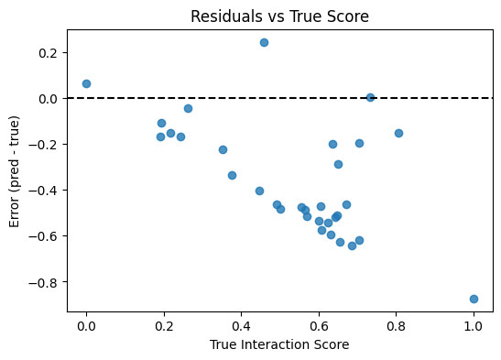

**Error Distribution**

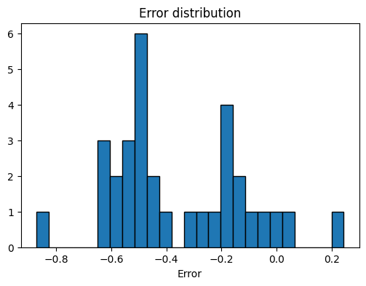

**Comparison of Moschamine Vs top 10 Worst predicted compounds**

